ASSIGNMENT 6.4

1.Write a pig script find the average age of male and female persons died in the titanic tragedy.

1.TO LOAD TITANIC_DATA.txt FILE INTO relload AND DUMP IT: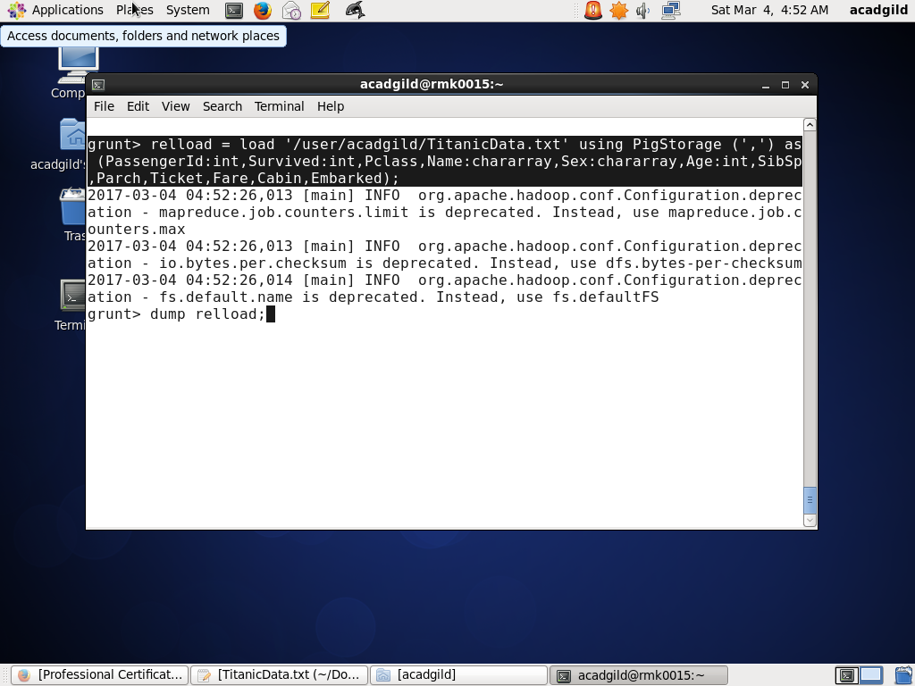

2. FILTER COMMAND TO FILTER THE PEOPLE DIED IN TRAGEDY:

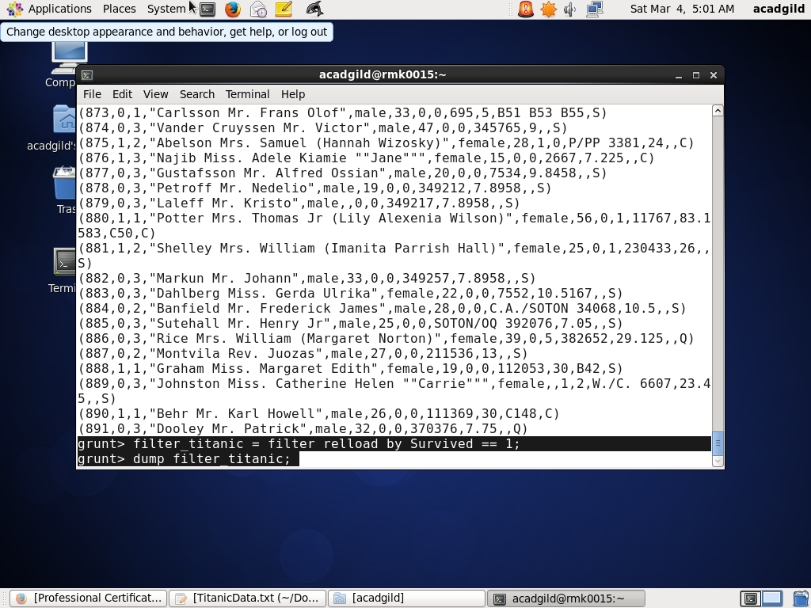  
3. GROUP DATA BASED ON THE GENDER(SEX)

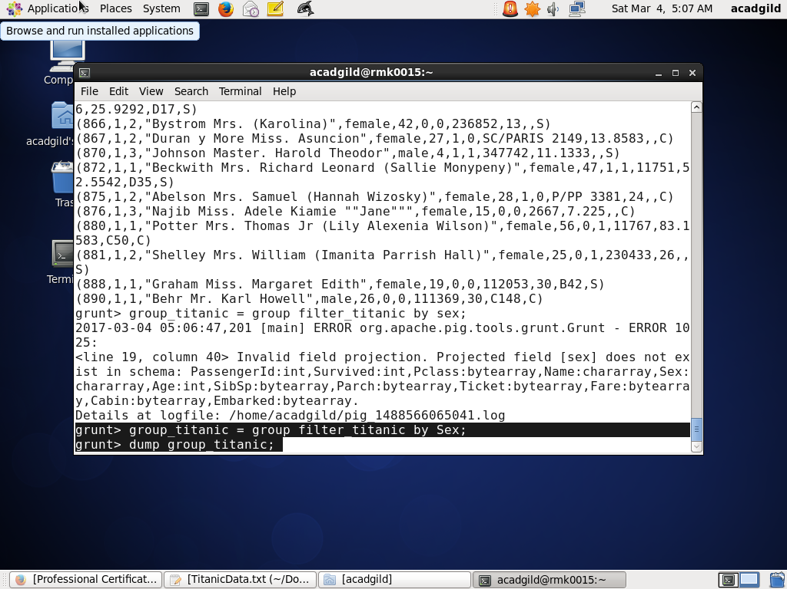

4. AVG COMMAND TO FIND AVERAGE OF PEOPLE OF BOTH GENDER

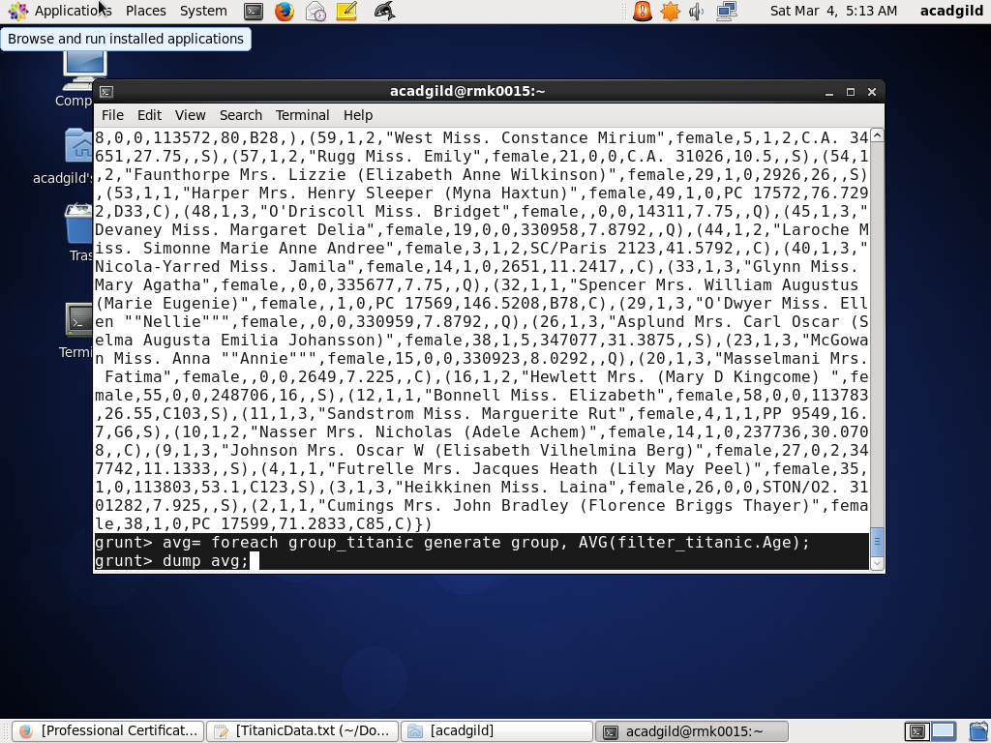

5. OBTAINED AVERAGE SOLUTION

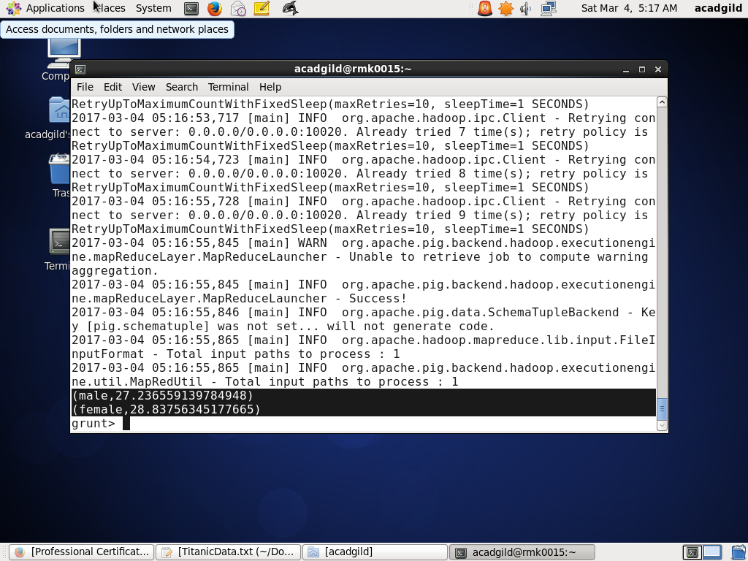

2) Write a pig script to find the number of people died and survived in each class.

A) NO.OF PEOPLE DIED IN TRAGEDY

1.LOAD TITANIC DATA INTO reload

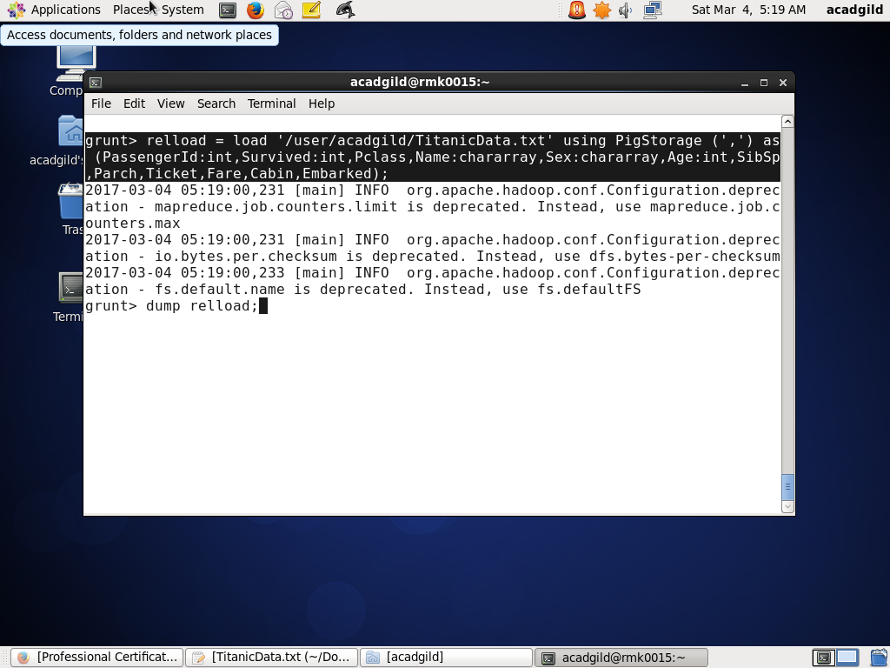

2.USE FILTER TO CHECK WHO DIED IN TRAGEDY

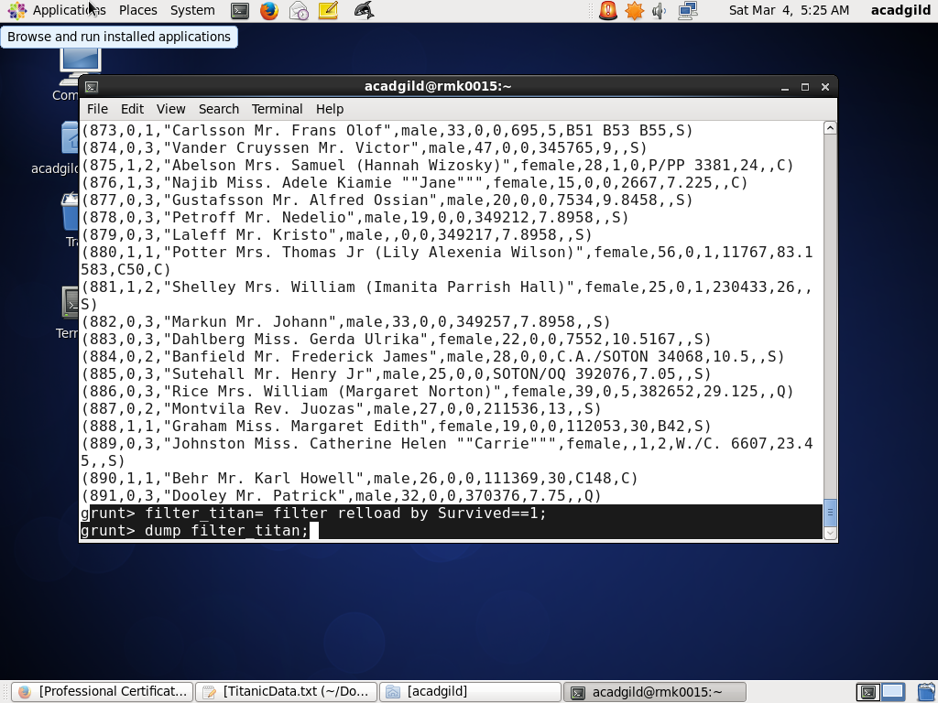

3.GROUPING DATA BY PCLASS

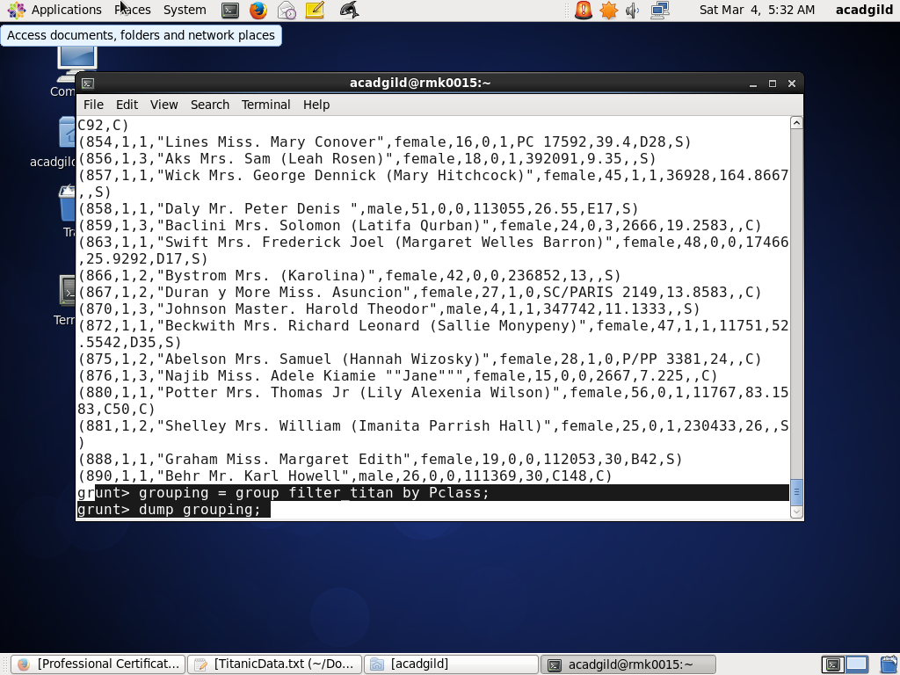

4. COUNT COMMAND TO COUNT PEOPLE DIED IN EACH CLASS

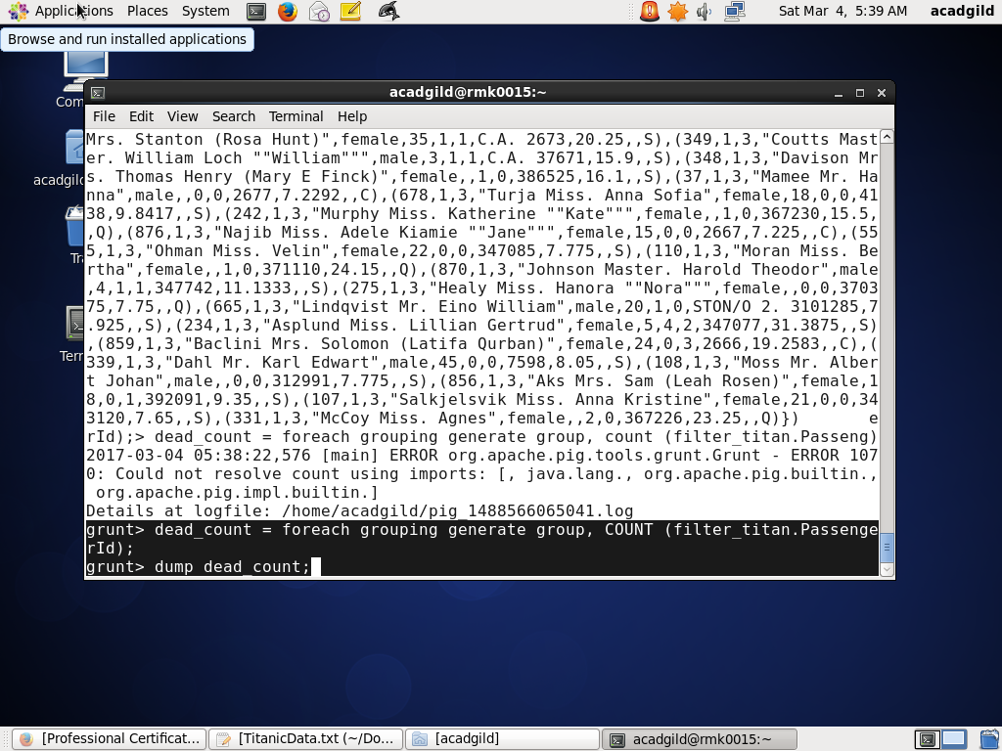

5.COUNT OF PEOPLE DIED IN EACH CLASS

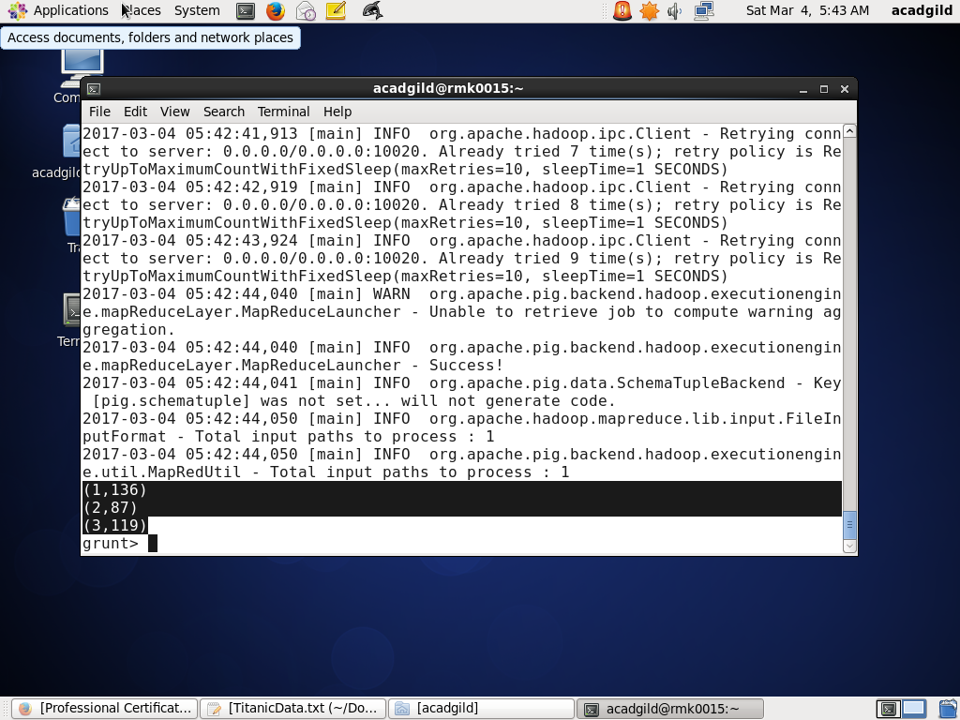

2) B) NO.OF PEOPLE SURVIVED IN TRAGEDY

1.LOAD TITANIC DATA INTO reload



2. USE FILTER TO CHECK WHO SURVIVED IN TRAGEDY

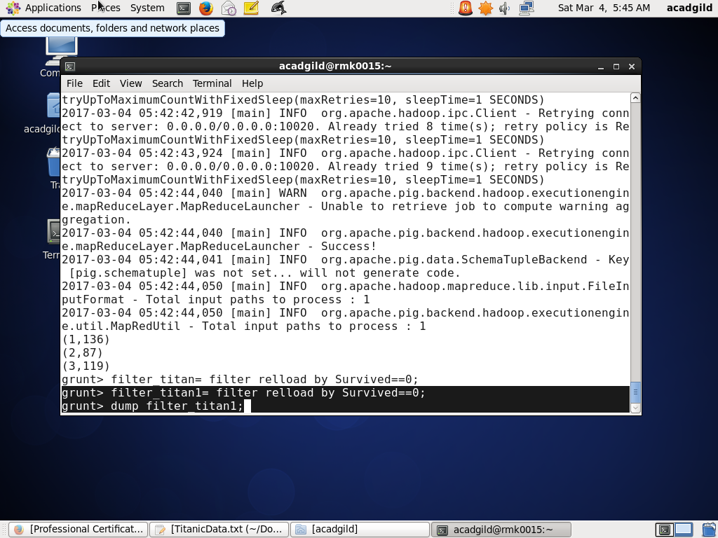

3.GROUPING DATA BY PCLASS

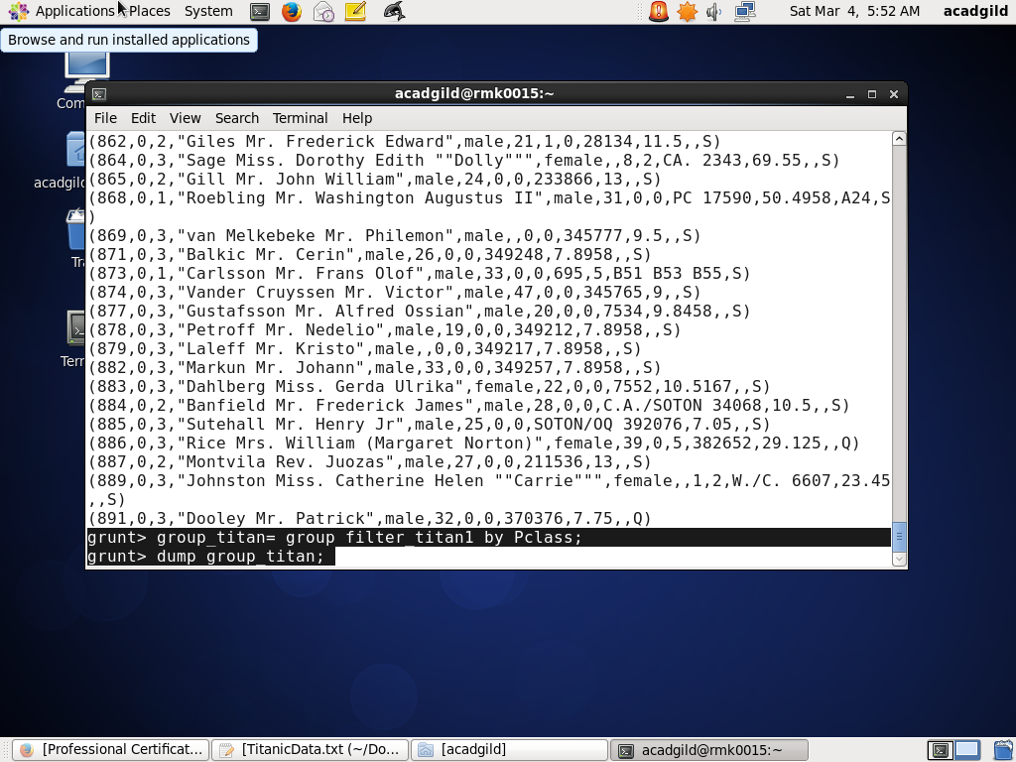

4. COUNT COMMAND TO COUNT PEOPLE SURVIVED IN EACH CLASS

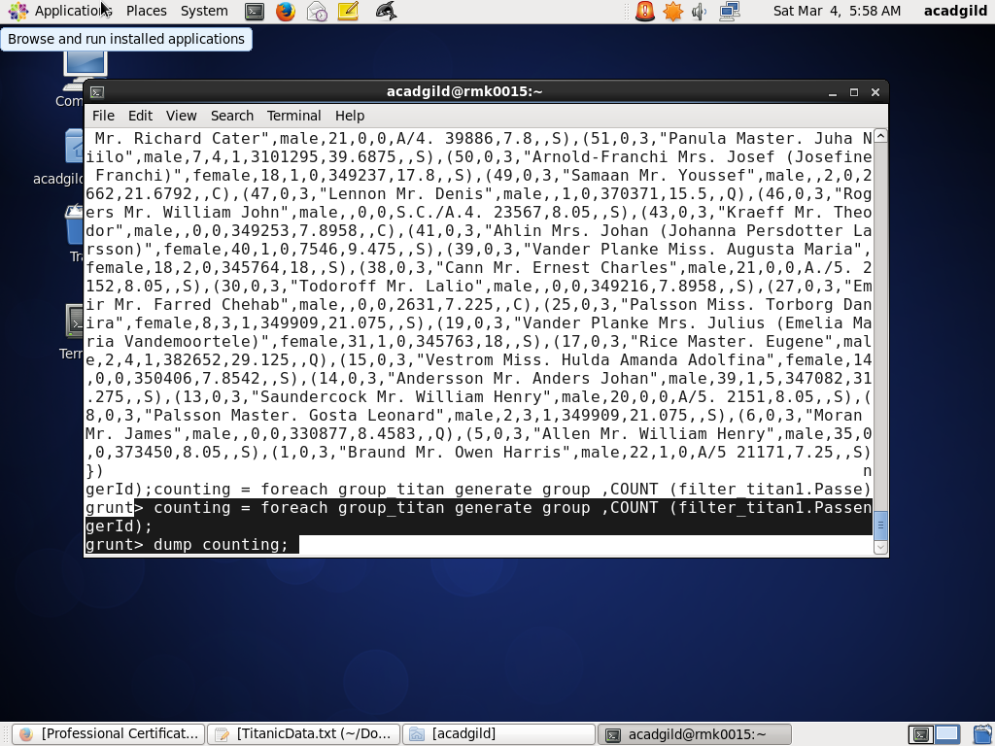

5. TOTAL PEOPLE SURVIVED IN TRAGEDY

